http://www.cpsc.gov/cpscpub/prerel/prhtml09/09265.html

NEWS from CPSC

U.S. Consumer Product Safety Commission
Office of Information and Public Affairs | Washington, DC 20207

FOR IMMEDIATE RELEASE  July 8, 2009  Release # 09-265 | Firm’s Recall Hotline: (866) 594-4208  CPSC Recall Hotline: (800) 638-2772  CPSC Media Contact: (301) 504-7908  Kolcraft Media Contact: (202) 289-2001

Kolcraft Recalls 1 Million Play Yards Due to Fall Hazard
WASHINGTON, D.C. - The U.S. Consumer Product Safety Commission, in cooperation with the firm named below, today announced a voluntary recall of the following consumer product. Consumers should stop using recalled products immediately unless otherwise instructed.
Name of Product: Kolcraft, Carter’s, Sesame Street, Jeep, Contours, Care Bear and Eric Carle Play Yards
Units: About 1 million
Distributor: Kolcraft Enterprises Inc. of Chicago, Ill.
Hazard: The play yard’s side rail can fail to latch properly and when a child pushes against the rail it can unlatch unexpectedly, posing a fall hazard to children.
Incidents/Injuries: The firm has received 347 reports of sides of the play yard collapsing unexpectedly, resulting in 21 injuries to young children, including bumps, scrapes, bruises and one concussion.
Description: This recall involves the Kolcraft Travelin’ Tot play yards, as well as other similar play yards manufactured for Carter’s, Sesame Street, Jeep, Contours, Care Bare and Eric Carle, with model numbers listed below. Some of the units have a bassinet and/or changing table. Some models have a mobile, vibrating unit or a parent organizer. Model numbers are printed on a white sticker on one of the feet of the play yard.
Play Yard | Model Numbers | Additional Information
Kolcraft Travelin’ Tot,  Kolcraft Travelin’ Tot LTD,  Kolcraft Travelin’ Tot 2-in-1,  Kolcraft Travelin’ Tot 3-in-1,  Kolcraft Travelin’ Tot 4-in-1 | 18709-BH, 18709T-BH, 18709T-DV, 18709-NF, 18709T-NF, 18710-BE, 18711T-BD, 18711T-BE, 18713T-LB, 18714T-WD, 18714-WD, 18724T-SQ, 18725-CG, 18725T-FF, 18730T-BZ, 18730T-HJ,18731- DV, 18731T-BZ, 18733-CU, 18733T-CU, 18734T-DV, 18744-BL, 18751T-BZ, 18751T-CU,18751-DV,18751T-DV, 18910-MQ, 18910T-EB, 18910T-LN,18920D-OW,18920-OW, 18925-GS, 18925-LA, 18931-EZ, 18931T-DV, 18931T-PV, 18933T-CU, 18934-SW, 18934-DV, 18935T-UT, 18935-CH, 18942-EC, 18945T-CT, 18945T-ER, 18946-AR, 18950-GV, 18950T-GV, 18951T-DV, 18951T-GS, 18951T-MO,18960-KK, 18960T-PP, 18961-AR, 18961T-AR, 18961-CT, 18961T-CT, 18961-PP, 18961T-GF, 18961T-RV, 18962-AX, 18962T-FZ, 18962-OQ, 18962T-ZT, KP001-BND, KP013-BPA, KP013-HGF, KP013-JFR, KP013-NRB, KP013-PPL, KP014-JGY, KP015-BPA, KP015-JFR, KP016-OW, KP027-JGX | “Kolcraft” and “Travelin’ Tot” are printed on either the fabric on the top rail or on the lower side of the play yards.
Carter’s Lennon Travelin’ Tot,  EMU Carter’s Travelin’ Tot,  Carter’s Travelin’ Tot | 18740-UE, 18740T-UE, 18736T-LJ, 18737-LJ, 18737T-LJ, 18726-KA, 18726T-HM | “Carter’s" and “Travelin’ Tot” are printed on the top rail.
“Sesame Beginnings” 2-in-1 Play Yard by Kolcraft,  Sesame Travelin’ Tot VT | 22361-VT  SP001-SBK  SP004-SBK | “Sesame Beginnings” and “Travel Play Yard Kolcraft” are printed on the top rail or along the fabric draft guard on the lower side of the play yards.
Jeep Sahara, Jeep Sahara SE Play Yard,  Jeep Sahara Limited Play Yard,  Jeep Sahara XT Play Yard,  Jeep Sahara Limited SE Play Yard,  Jeep Sahara Limited XT Play Yard | 55200-JC, 55220-JC, 55225-JC, 55225T-JC, 55235-JC, 55237-JQ, 55237T-JQ, 55237-XC, 55237-XV, 55237T-XB, 55770-XA, 55770-XI, 55772-XE, 55773-XY, JP002-XSP | “Jeep” and “Sahara” are printed on the fabric on the top rail of the play yards.
Contours 2-in-1 Travel Playyard,  Contours 3-in-1 Play Yard,  Contours Deluxe Playyard,  Contours Travel Play Yard | 18604-OC  ZP001-MON  ZP001-MYS  ZP003-MAL  ZP004-MAL | “Kolcraft” and “Contours” are printed along the draft guard on the lower side of the play yards.
Care Bear Play Yard | 18960-KK
Eric Carle Play Yard with Activity Gym | 18763-EK  18763T-EK
Sold at: Babies R Us, Walmart, Kmart, Sears, Target and other stores nationwide and Internet retailers from January 2000 through January 2009 for between $50 and $160.
Manufactured in: China, Spain, and Italy
Remedy: Consumers should immediately stop using the play yard and contact Kolcraft for a free repair kit.
Consumer Contact: For additional information, contact Kolcraft toll-free at (866) 594-4208 anytime or visit the firm’s Web site at www.kolcraft.com
Note: Some of the models of the play yards involved in this recall were recalled in September 2007 due to a strangulation hazard posed by the changing table, which resulted in the death of a 10-month child.
To see a video of this product click here.

Kolcraft Travelin’ Tot Series
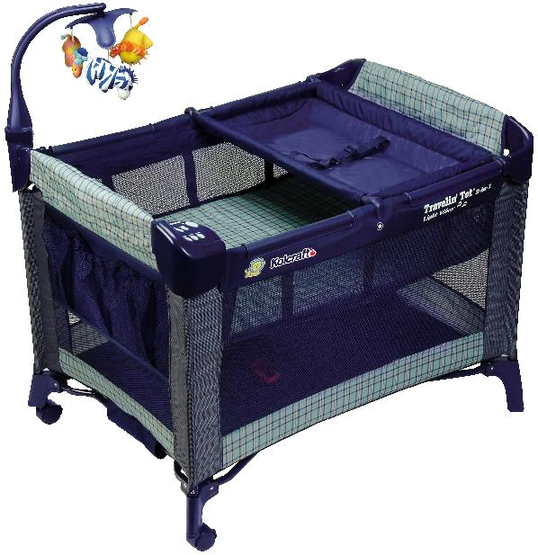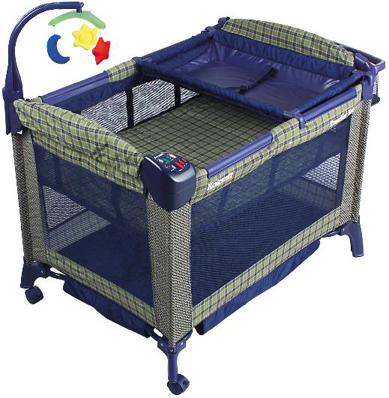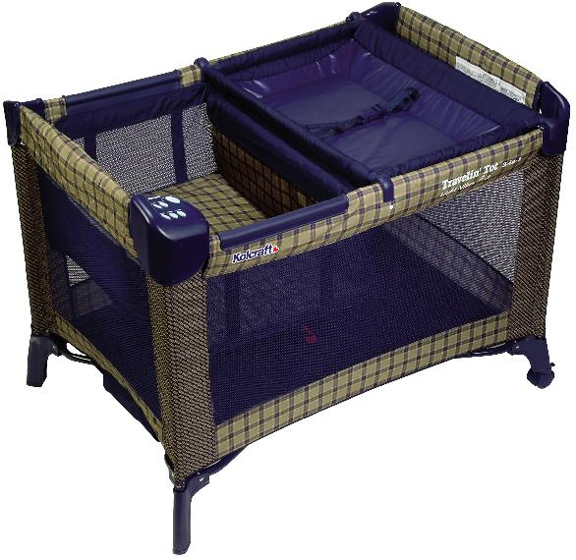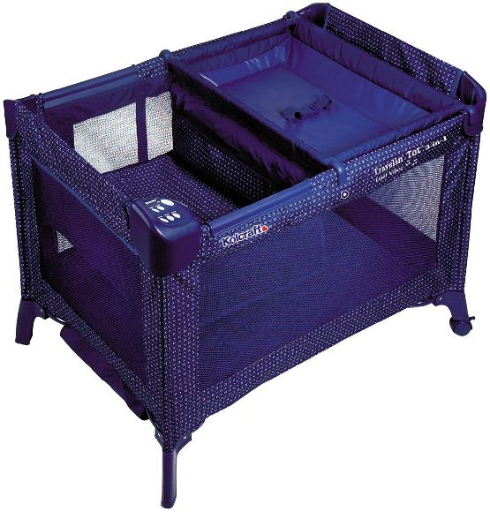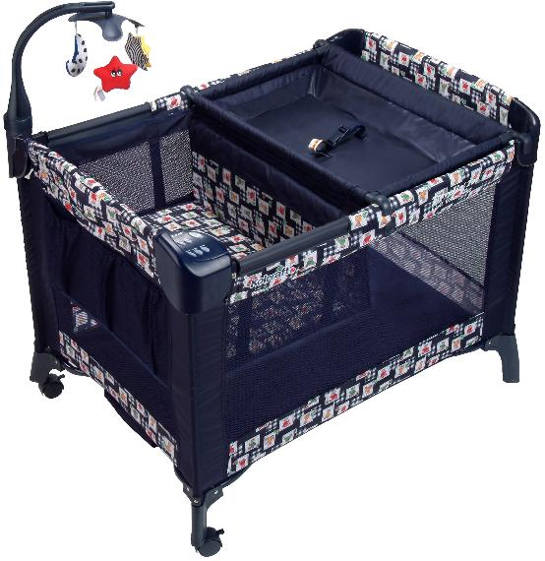

Contours 3-in-1 Play Yards
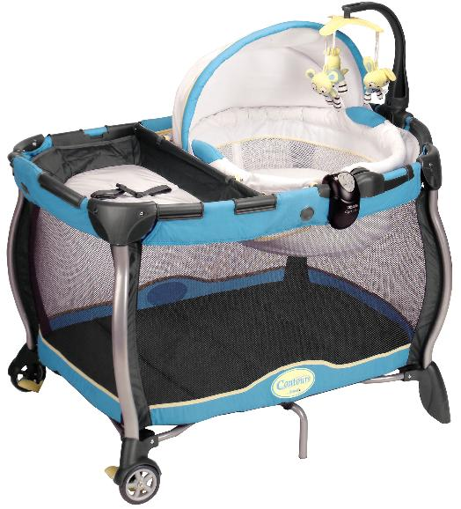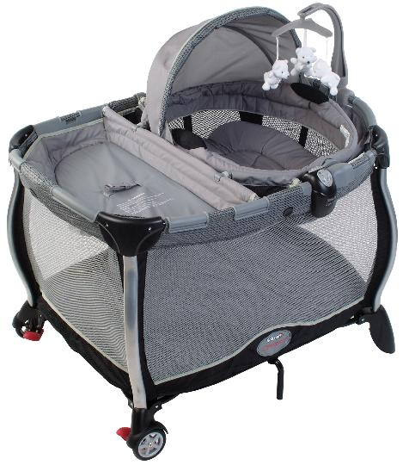

“Sesame Beginnings”
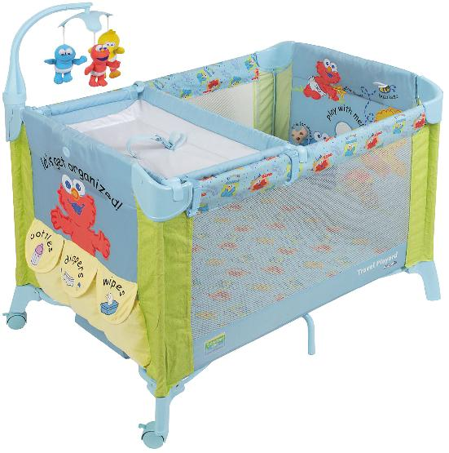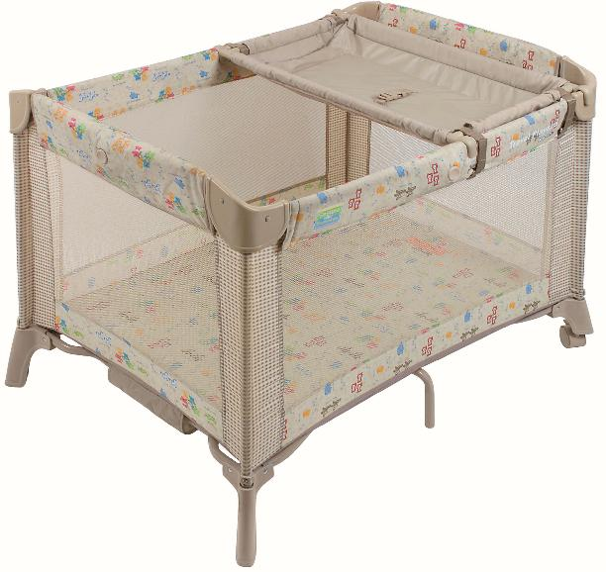

Carter’s Lennon Travelin’ Tot
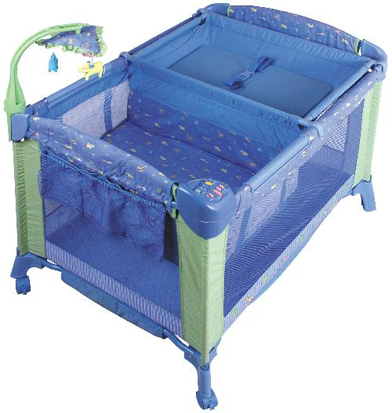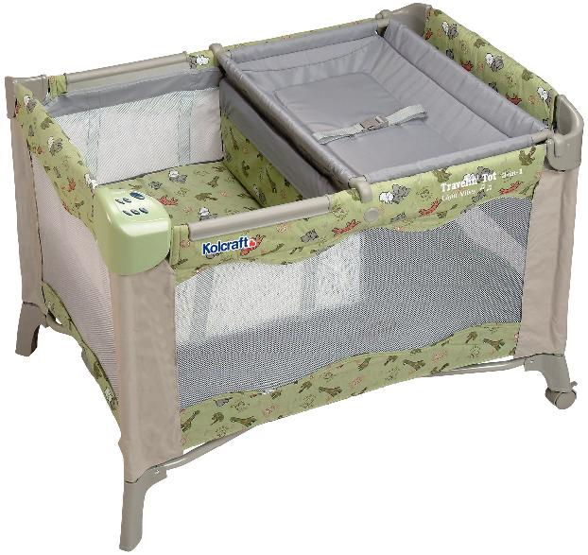

Jeep Sahara Series
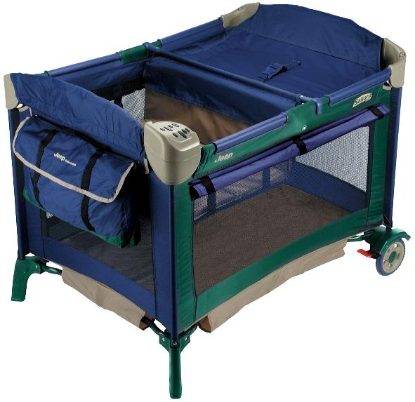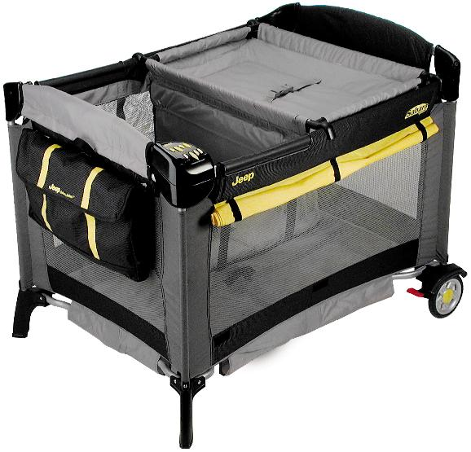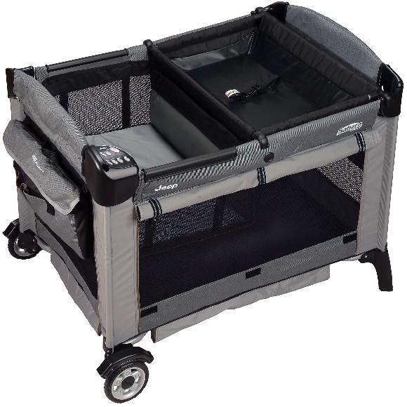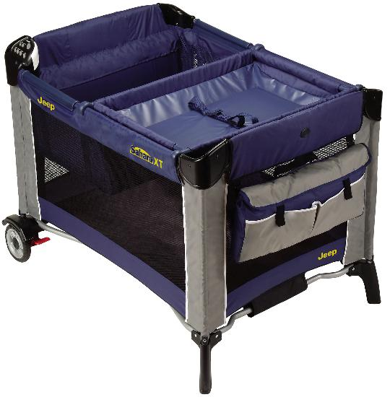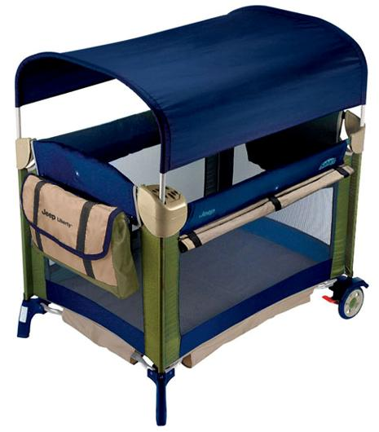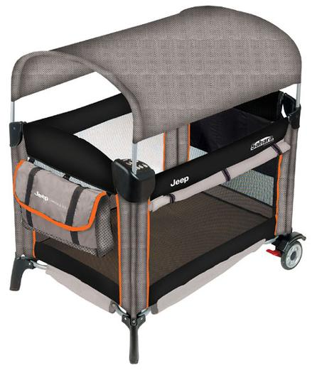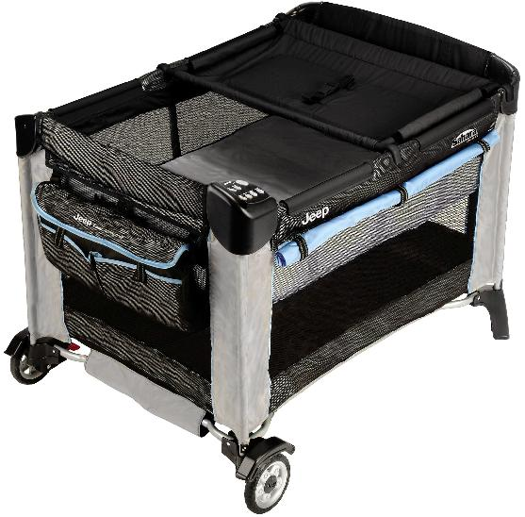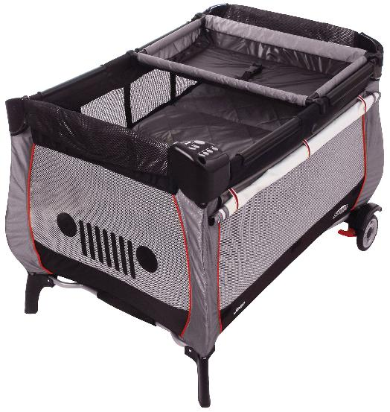
CPSC is still interested in receiving incident or injury reports that are either directly related to this product recall or involve a different hazard with the same product. Please tell us about it by visiting https://www.cpsc.gov/cgibin/incident.aspx
---
Send the link for this page to a friend! The U.S. Consumer Product Safety Commission is charged with protecting the public from unreasonable risks of serious injury or death from thousands of types of consumer products under the agency's jurisdiction. The CPSC is committed to protecting consumers and families from products that pose a fire, electrical, chemical, or mechanical hazard. The CPSC's work to ensure the safety of consumer products - such as toys, cribs, power tools, cigarette lighters, and household chemicals - contributed significantly to the decline in the rate of deaths and injuries associated with consumer products over the past 30 years.
To report a dangerous product or a product-related injury, call CPSC's Hotline at (800) 638-2772 or CPSC's teletypewriter at (800) 638-8270. To join a CPSC e-mail subscription list, please go to https://www.cpsc.gov/cpsclist.aspx. Consumers can obtain recall and general safety information by logging on to CPSC's Web site at www.cpsc.gov.

