http://www.cpsc.gov/cpscpub/prerel/prhtml09/09262.html

NEWS from CPSC

U.S. Consumer Product Safety Commission
Office of Information and Public Affairs | Washington, DC 20207

FOR IMMEDIATE RELEASE  July 7, 2009  Release # 09-262 | Firm’s Recall Hotline: (973) 458-9399  CPSC Recall Hotline: (800) 638-2772  CPSC Media Contact: (301) 504-7908

Pacifiers Recalled by Gromex Due to Choking Hazard
WASHINGTON, D.C. - The U.S. Consumer Product Safety Commission, in cooperation with the firm named below, today announced a voluntary recall of the following consumer product. Consumers should stop using recalled products immediately unless otherwise instructed.
Name of Product: Jaloma Pacifiers
Units: About 700
Importer: Gromex Inc., of Passaic, N.J.
Hazard: The pacifier mouth guard and the ventilation holes are too small and fail to meet federal safety standards. The pacifier could pose a choking and aspiration hazard to young children.
Incidents/Injuries: None reported.
Description: This pacifier has a ring-shaped handle and a round-shaped mouth guard with two ventilation holes. “Jaloma” is printed on the handle side of the mouth guard and the nipple has a gel-like liquid inside.
Sold at: Retail stores in New Jersey and New York from February 2008 through March 2009 for about $1.
Manufactured in: Mexico
Remedy: Consumers should immediately take the recalled pacifiers away from children and contact Gromex for a refund or exchange.
Consumer Contact: For additional information, contact Gromex collect at (973) 458-9399 Monday through Friday between 9 a.m. and 5 p.m. ET.
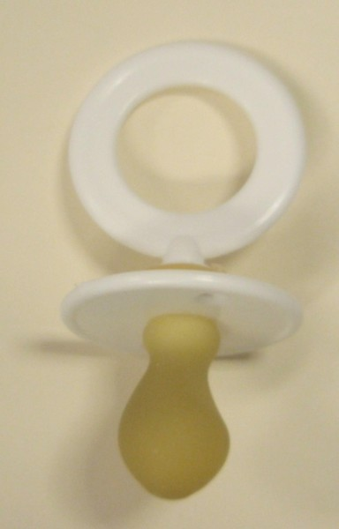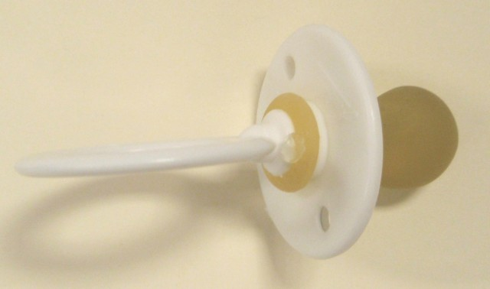
CPSC is still interested in receiving incident or injury reports that are either directly related to this product recall or involve a different hazard with the same product. Please tell us about it by visiting https://www.cpsc.gov/cgibin/incident.aspx
---
Send the link for this page to a friend! The U.S. Consumer Product Safety Commission is charged with protecting the public from unreasonable risks of serious injury or death from thousands of types of consumer products under the agency's jurisdiction. The CPSC is committed to protecting consumers and families from products that pose a fire, electrical, chemical, or mechanical hazard. The CPSC's work to ensure the safety of consumer products - such as toys, cribs, power tools, cigarette lighters, and household chemicals - contributed significantly to the decline in the rate of deaths and injuries associated with consumer products over the past 30 years.
To report a dangerous product or a product-related injury, call CPSC's Hotline at (800) 638-2772 or CPSC's teletypewriter at (800) 638-8270. To join a CPSC e-mail subscription list, please go to https://www.cpsc.gov/cpsclist.aspx. Consumers can obtain recall and general safety information by logging on to CPSC's Web site at www.cpsc.gov.

